# Question - 2

MyMainScript 1

Your code here 1

Solution for 2-a 1

Solution for 2-b 2

Solution for 2-c 10

Solution for 2-d 17

Solution for 2-e 20

## MyMainScript

tic;

## Your code here

## Solution for 2-a

Foreground masking is done to segment out the foreground image by separating the background from the image. This is done by distinguishing between the foreground and the background of the image using a threshold value, which in our case we took the mean of all intensity values in the image.

Observations:

The obtained binary mask clearly subtracts all the unnecessary background details from the original image and provides us a detailed foreground image. Using this, we obtain the masked image by pixel wise multiplication of the original image with the binary mask.

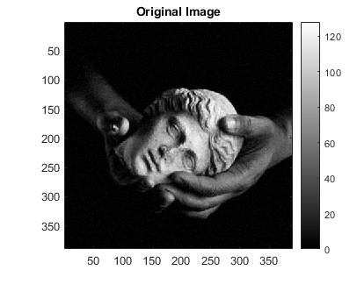myForegroundMask(); % 2.a

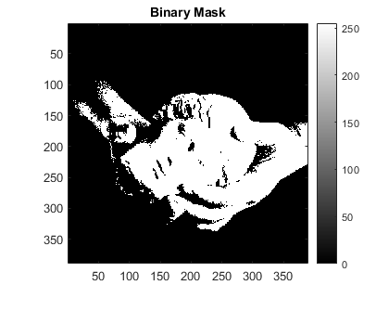

## 

## Solution for 2-b

Linear contrast stretching is used to increase the contrast in the image by linearly stretching the possibly limited intensity values to its full range, thereby improving the visibility of the differences in the intensity values between two pixels. We performed this contrast stretching by mapping the 5% and 95% intensity values to 0 and 255 respectively. Note that this is done since otherwise, linear contrast stretching would have no effect on an image having even, say one pixel with these intensities.

We obtain these values under the assumption that the histogram of intensities follows a gaussian distribution. Hence, the points x1=µ-3 & x2=µ+3(where µ=mean and $σ$ =standard deviation) will provide us with the required intensities. Let these be p1 and p2 respectively. Thus, the transformation function should be of the form y = mx + c, where ‘x’ represents intensity of the original image, and ‘y’ that of the output image. Therefore, we know that the points (p1,0) and (p2,255) lie on this line. Using this, we immediately get the formula of the transformation function:

$$y = \frac{255 - 0}{p_{2}-p_{1}}\left(x-p_{1}\right)+255$$

Observations:

The gaussian assumption was supported by the results obtained as they clearly show a significant increase in contrast as compared to the original image except for the 5th image. The 5th image is almost completely dark for most of the regions and almost completely white for the rest. So, it already has its intensity range to its maximum and hence the linear contrast stretching did not have any effect on it.

myLinearContrastStretching(); % 2.b

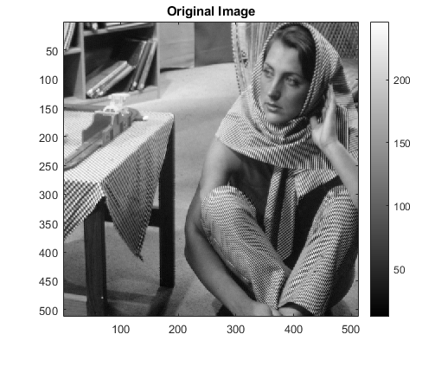

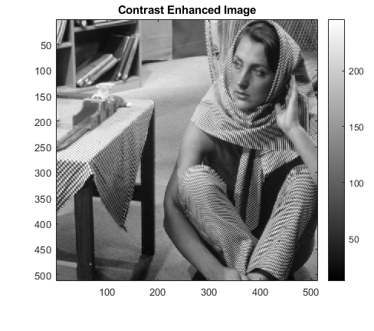

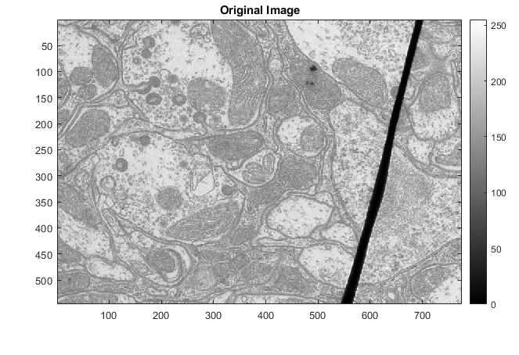

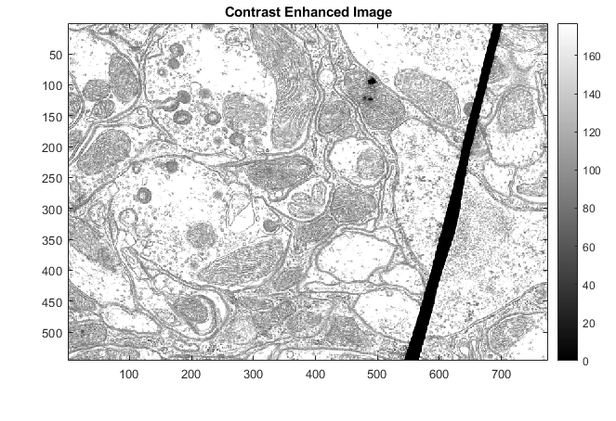

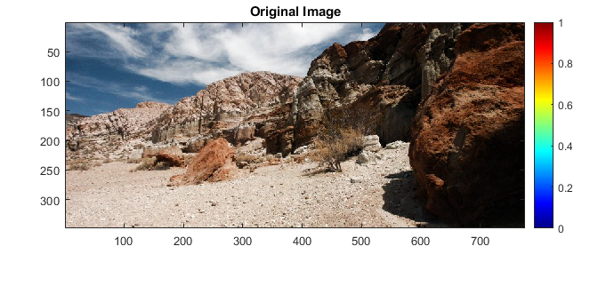

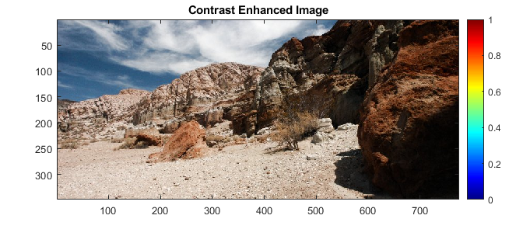

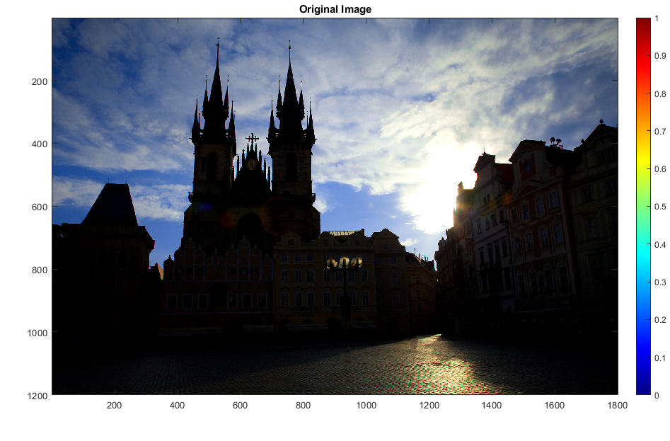

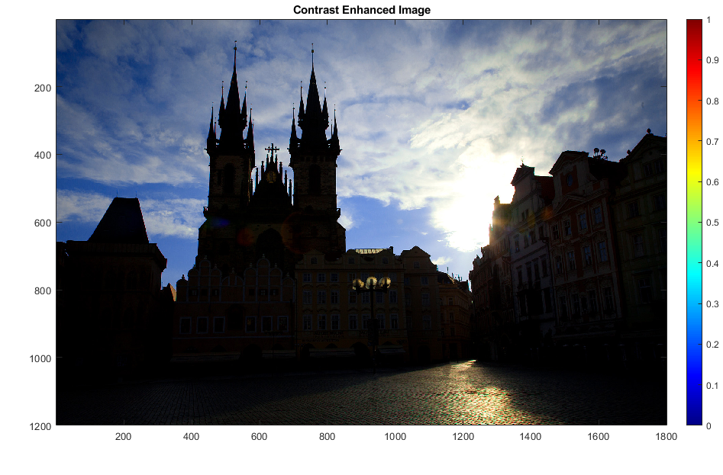

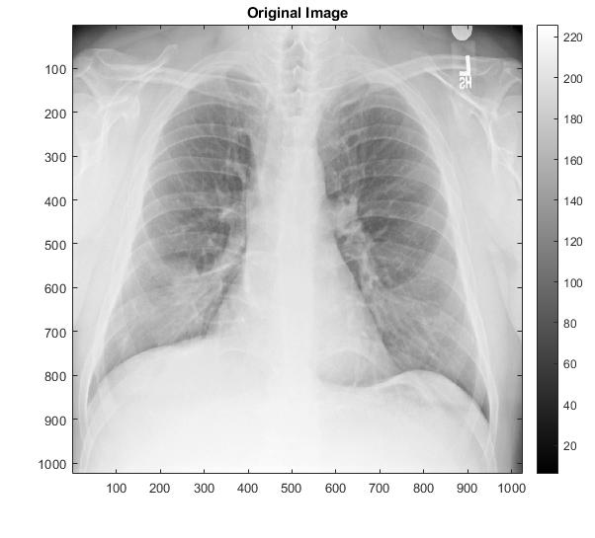

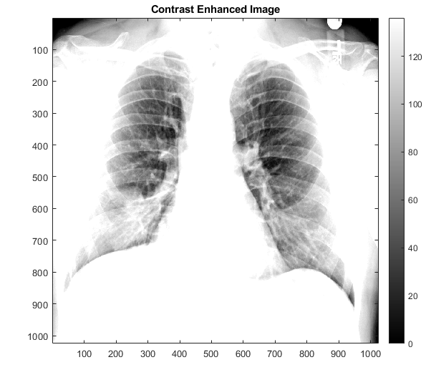

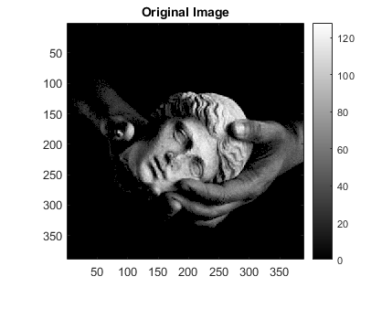

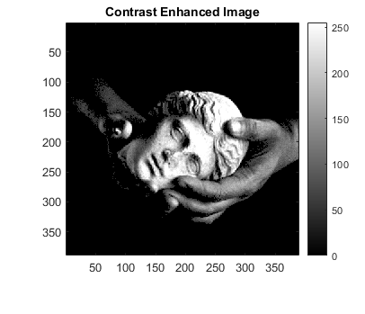

## Solution for 2-c

Histogram equalisation works on the principle of uniformly distributing all the intensity values over its full range to obtain a clearer image. This equalisation is performed using a transformation which maps the intensities to its corresponding value on the CDF (cumulative distribution function). Since we have a discrete distribution, our transformation results in somewhat (not exact) uniform distribution of the intensities, thereby improving the contrast of the image.

Observations:

It can be seen from the results that the histogram equalised images are significantly better than the original images. Even for the 5th image the high and low intensities are uniformly distributed and hence a clearer image is obtained unlike an unaffected image obtained using Linear contrast stretching. So clearly for improving an image such as the 5th image which has intensities only very high and very low, Histogram equalisation is a better choice than linear contrast stretching, since the latter will only map these peaks to the bigger range.

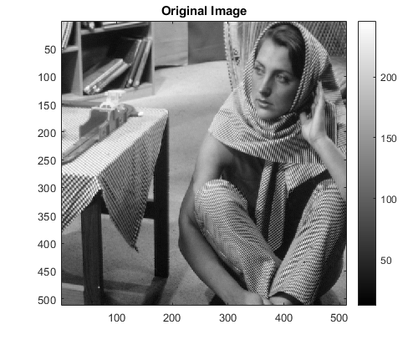myHE(); % 2.c

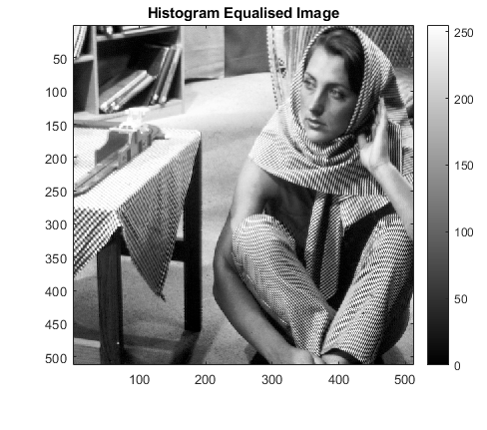

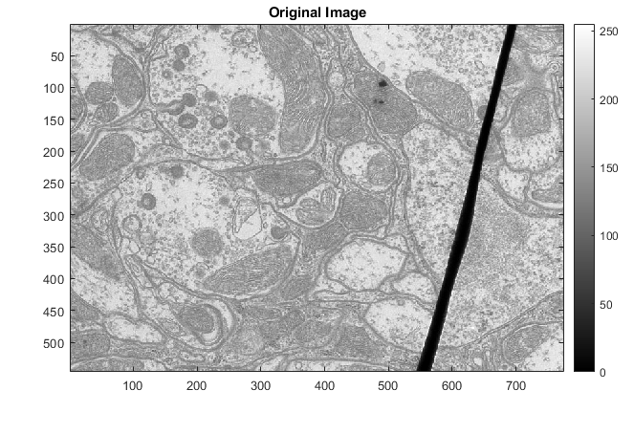

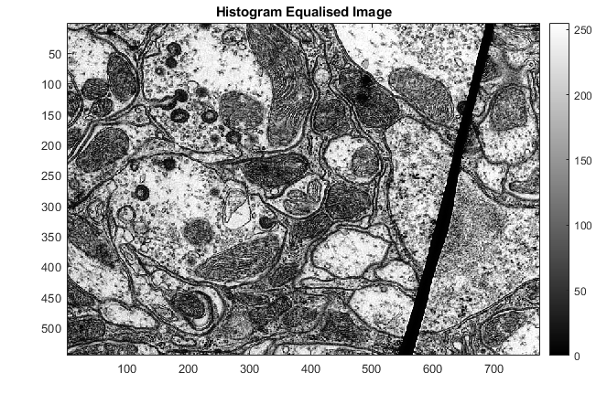

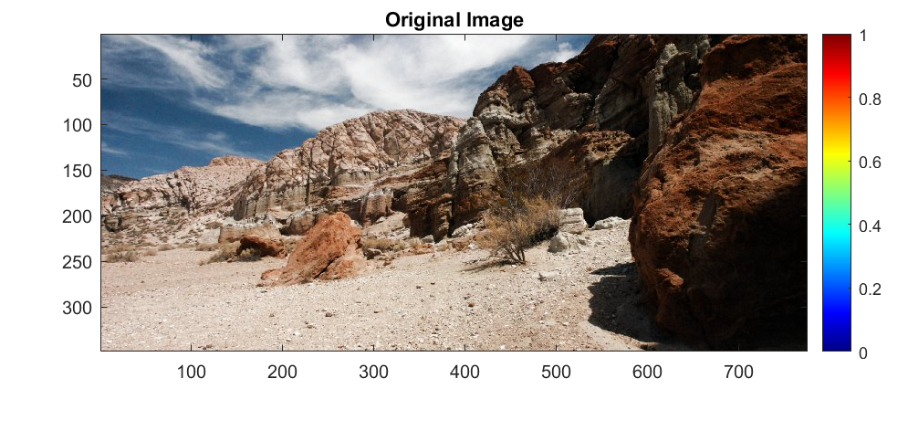

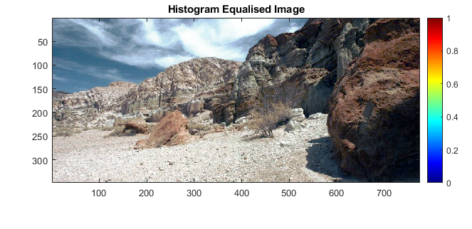

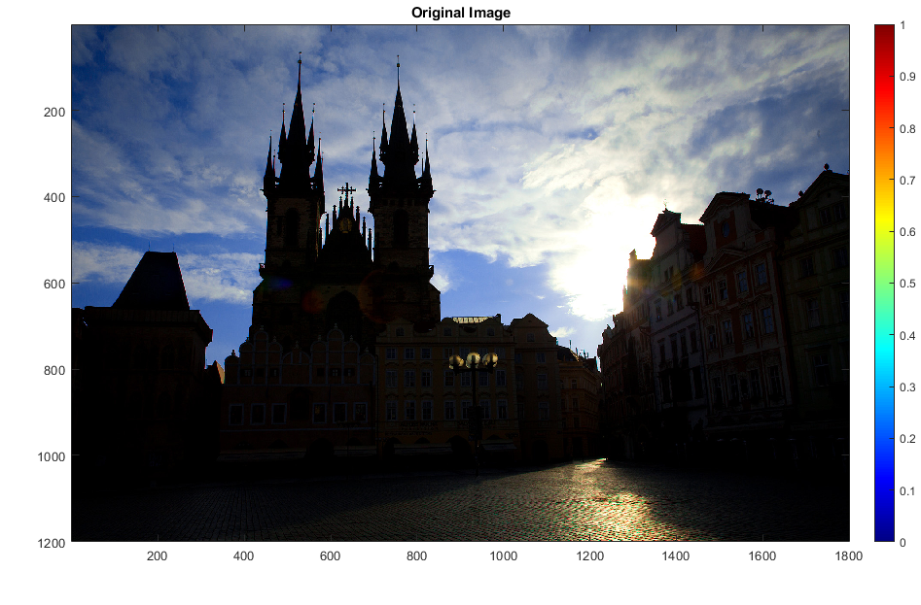

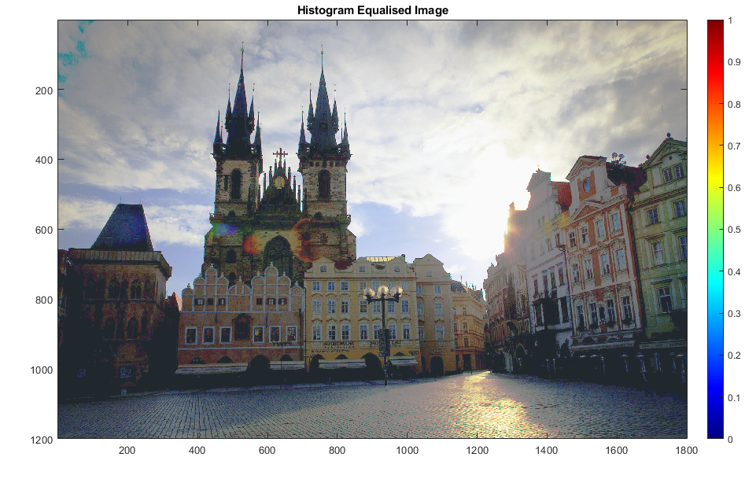

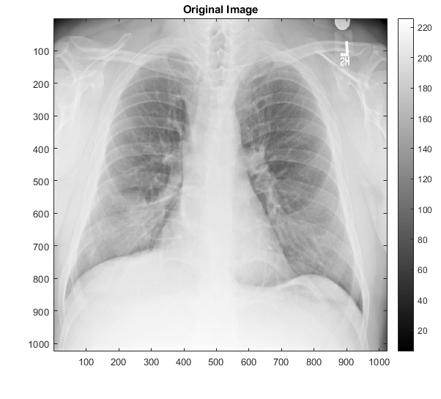

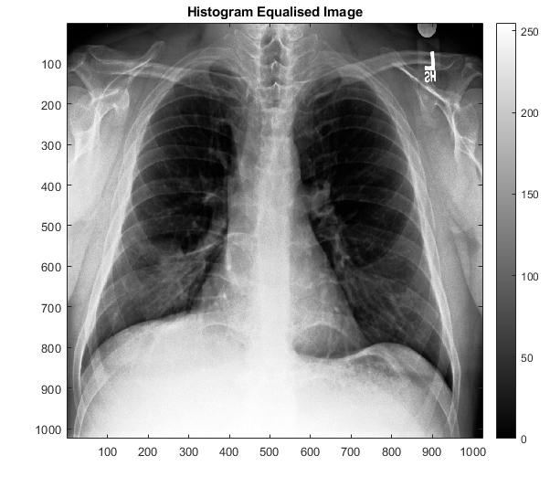

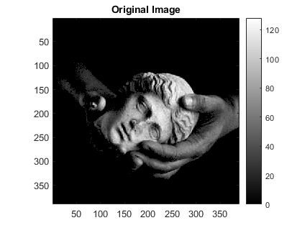

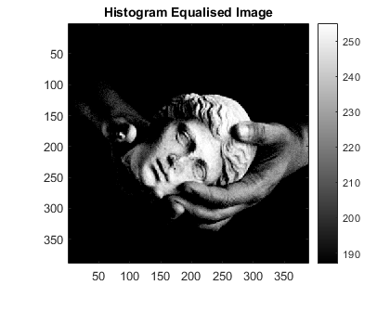

## Solution for 2-d

Histogram Matching is used when an image is required to be in a standardised form to perform the analysis. In our case we require the image of the retina to be standardised with respect to the reference retina image. This matching is performed using a transformation which includes a cascading of the CDF function of the image and the inverse CDF function of the reference image. Since we have a discrete distribution, for all the intensities which are not present in the image, we obtain a flat line in the CDF. For these we only take the leftmost values to obtain the inverse CDF mapping. Due to this the inverse CDF function has some missing points, which we fill by interpolating the values at previous intensities.

Observations:

It can be observed from the results that this interpolation works well as the histogram matched image is significantly standardised. The Histogram Equalised image is also presented to show the importance of Histogram Matching in these types of images.

myHM(); % 2.d

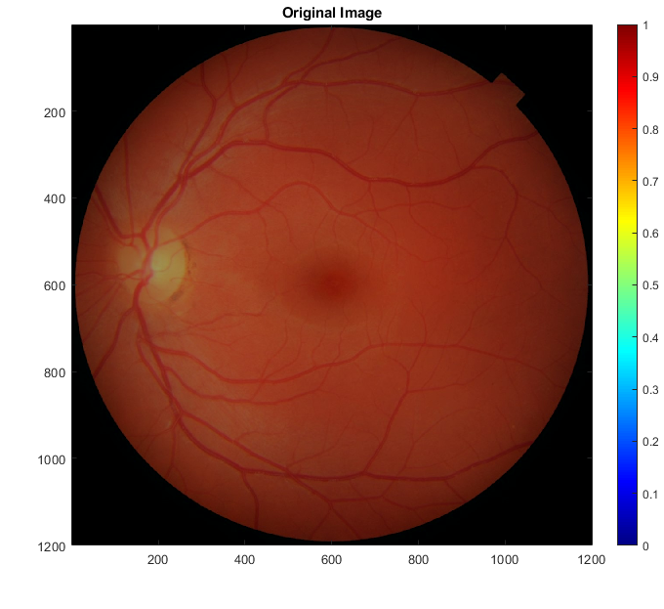

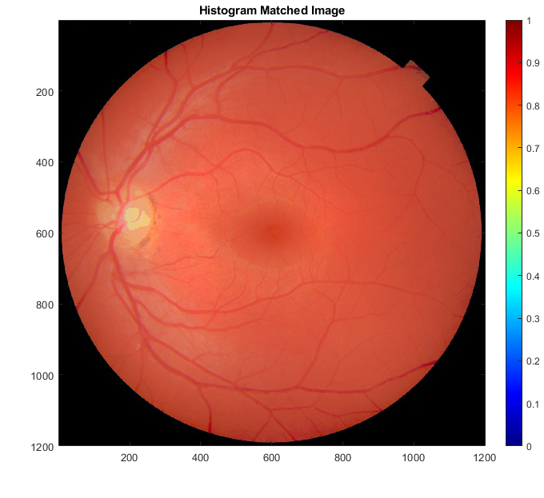

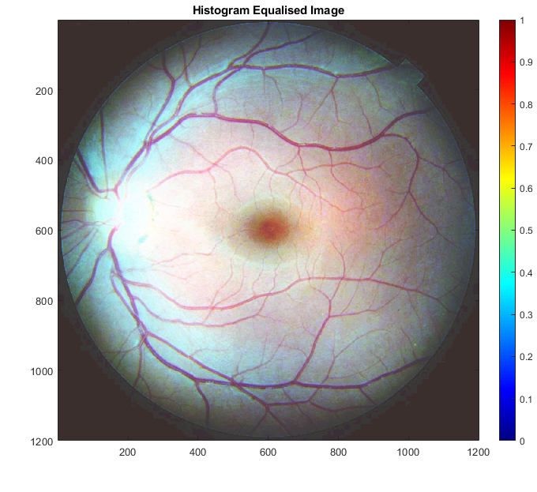

## Solution for 2-e

BestParameters = [105 0.009;  
 75 0.009;  
 101 0.001;  
 175 0.04];  
BestNames = ["barbara_best";"TEM_best";"canyon_best";"xray_best"];  
myCLAHE(BestParameters, BestNames);  
% Increase window size  
WLParameters = [750 0.009;  
 750 0.009;  
 750 0.001;  
 750 0.04];  
WLNames = ["barbara_large_window";"TEM_large_window";  
 "canyon_large_window";"xray_large_window"];  
myCLAHE(WLParameters, WLNames);  
% Decrease window size  
WSParameters = [25 0.009;  
 25 0.009;  
 25 0.001;  
 25 0.04];  
WSNames = ["barbara_small_window";"TEM_small_window";  
 "canyon_small_window";"xray_small_window"];  
myCLAHE(WSParameters, WSNames);  
% Half Threshold  
ThresholdParameters = [105 0.0045;  
 75 0.0045;  
 101 0.0005;  
 175 0.02];  
ThresholdNames = ["barbara_threshold";"TEM_threshold";  
 "canyon_threshold";"xray_threshold"];  
myCLAHE(ThresholdParameters, ThresholdNames);  
% Stay tuned! Coming soon  
toc;

**“Best” Tuned Results:**

Results obtained by eyeballing the best contrast enhancement with minimal noise amplification.

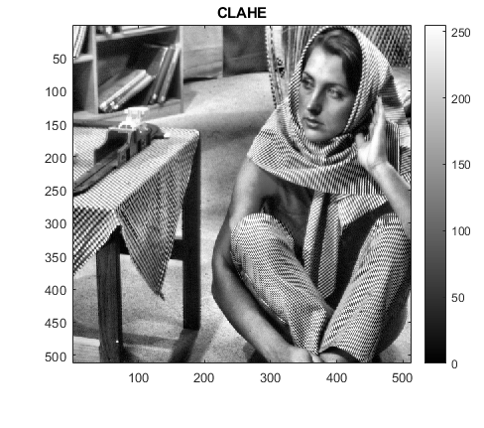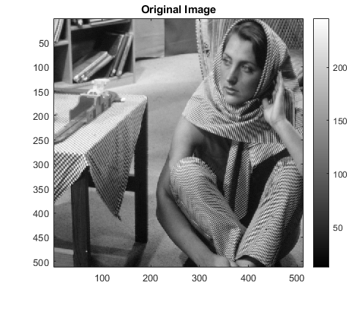

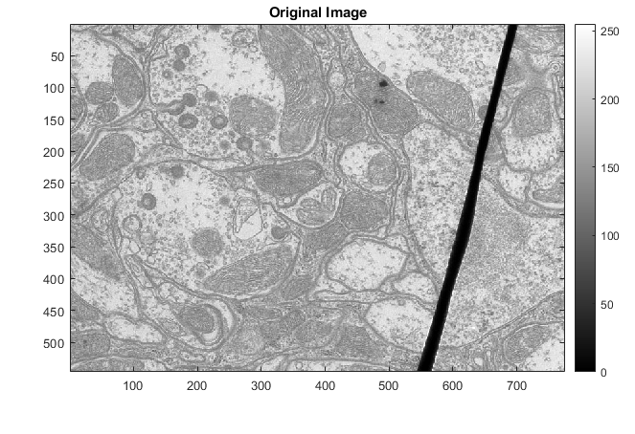

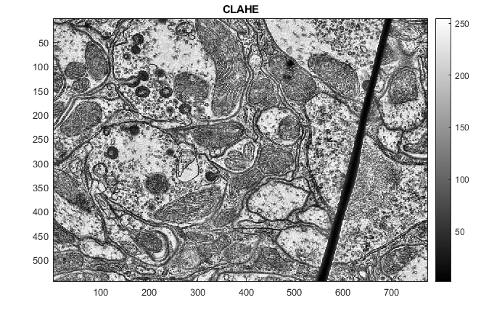

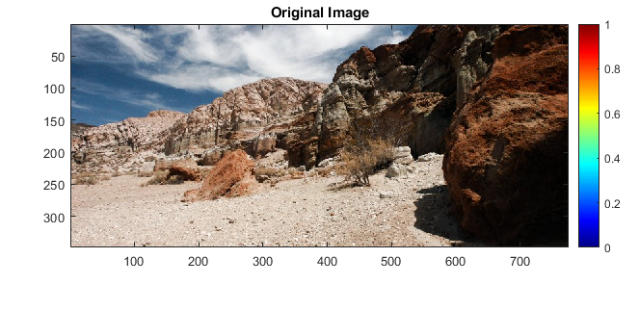

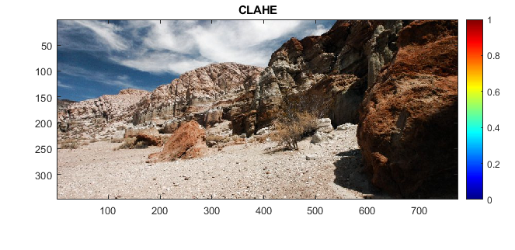

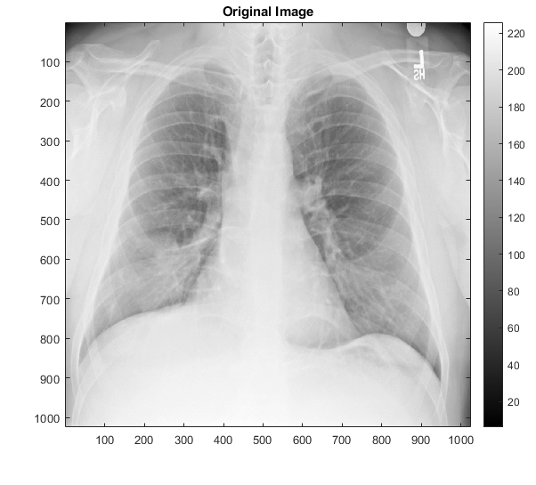

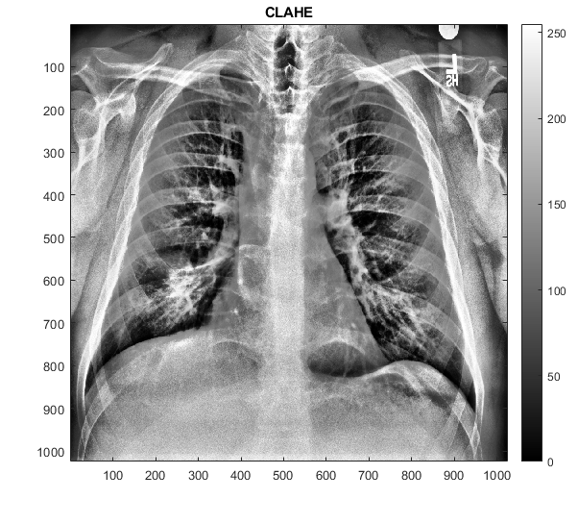

**Results for Increased window size:**

As expected, the contrast improvement worsens on increasing the window size, and approximates that obtained by vanilla histogram equalization – pixels aren’t differentiated enough from their immediate neighbours. This effect is particularly evident in the x-ray and TEM images, since they had regions of similar intensity close.

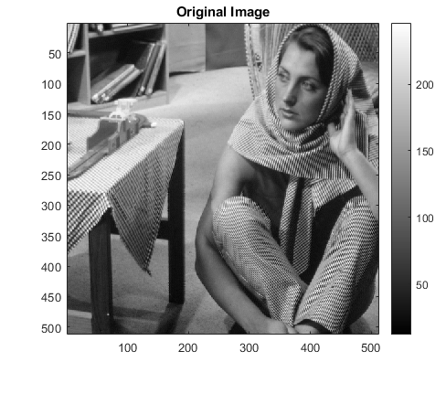

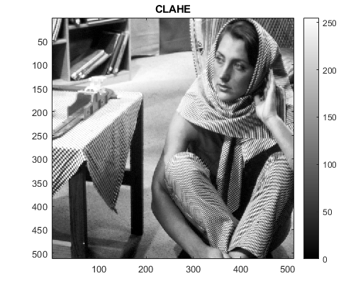

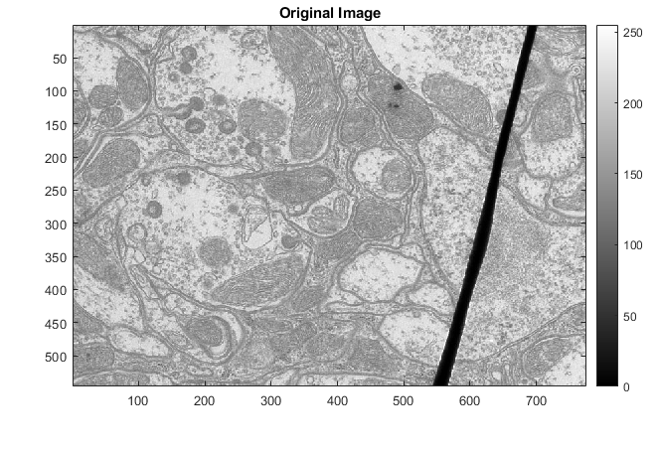

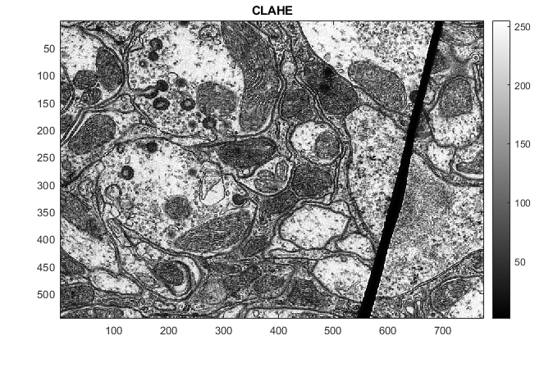

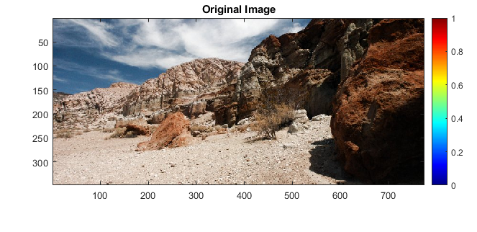

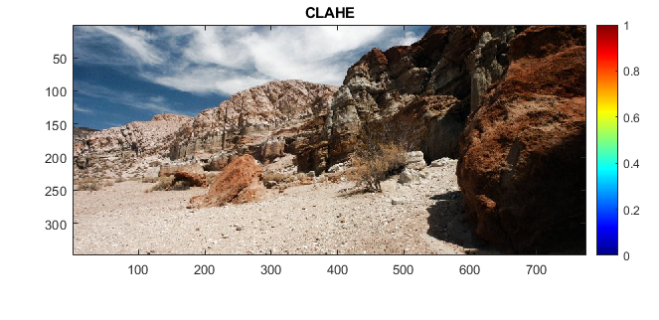

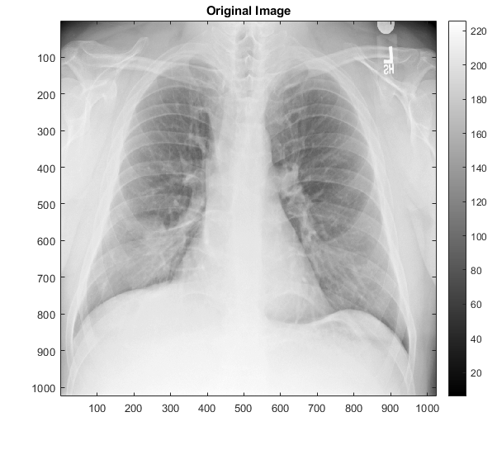

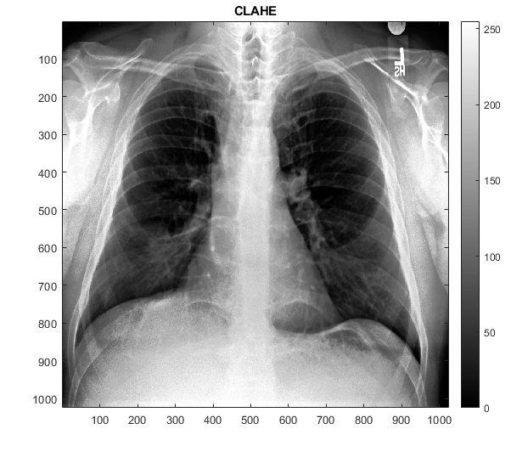

**Results for decreased window size:**

Pixels quite close to each other are differentiated in intensity values primarily by noise. Now for a window size that is too small, CLAHE will amplify this difference, leading to a noisy/grainy result.

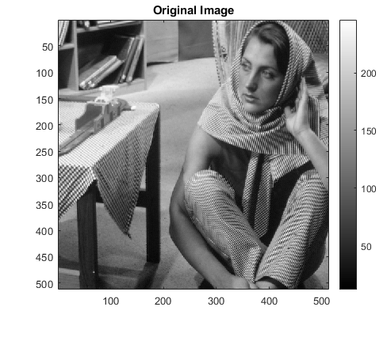

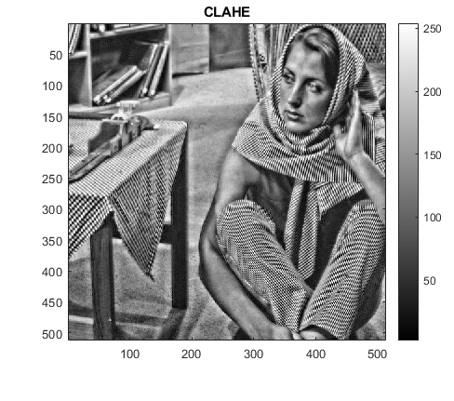

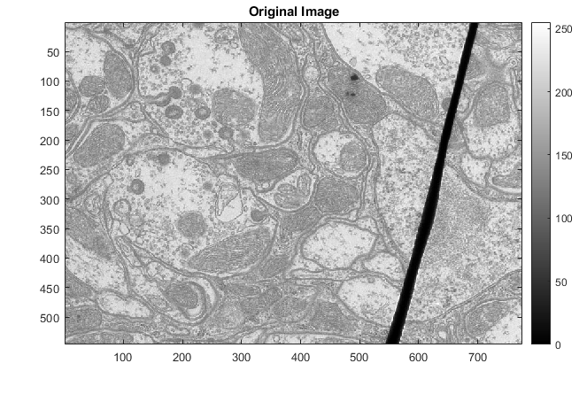

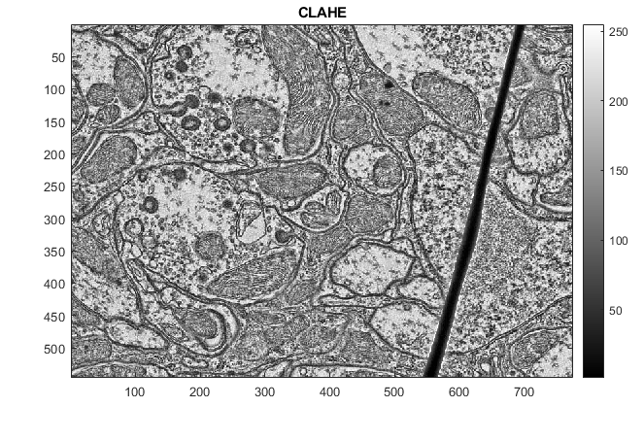

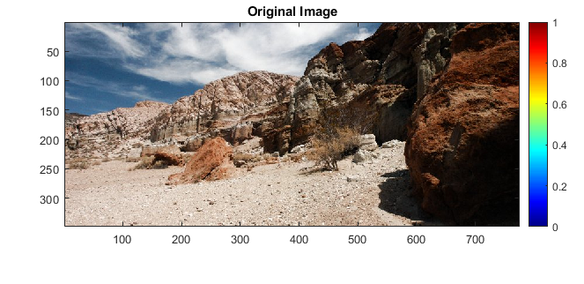

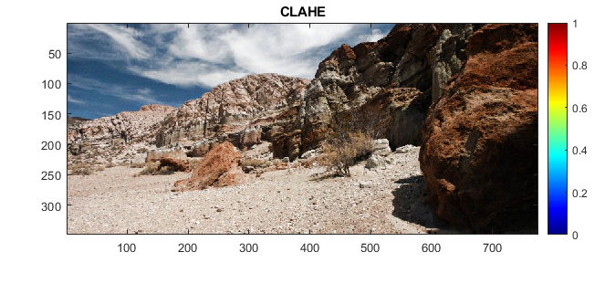

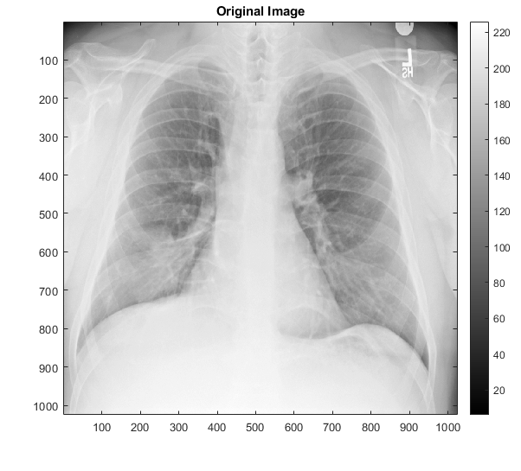

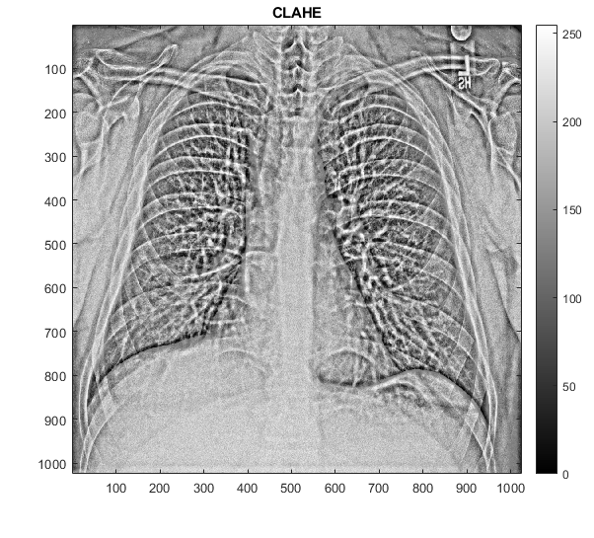

**Results for decreased threshold:**

A reduced threshold will imply that more of the probability mass in the window is clipped and distributed over the intensity range. Now the more the threshold is reduced, lower will be the slope of the resulting CDF used as the transformation and thus the contrast enhancement will reduce. The results are consistent with this reasoning.

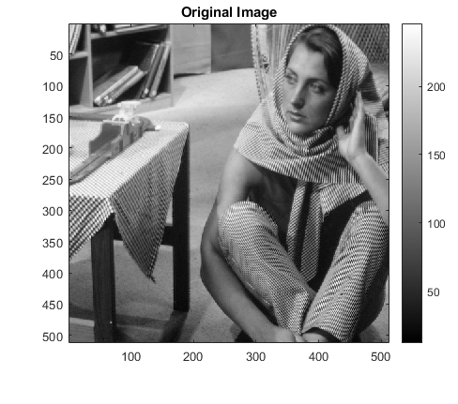

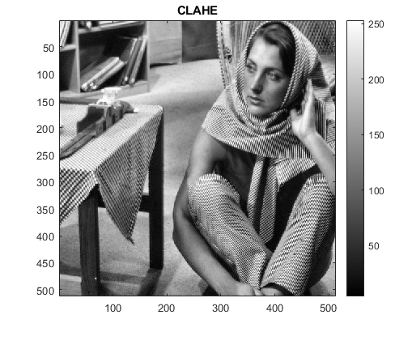

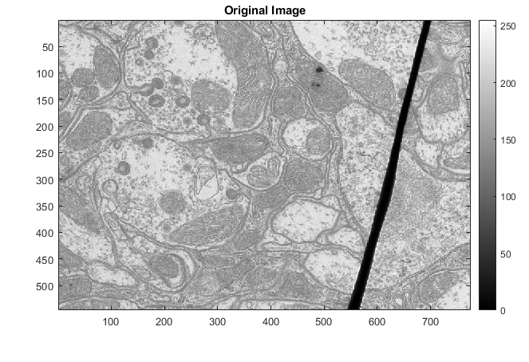

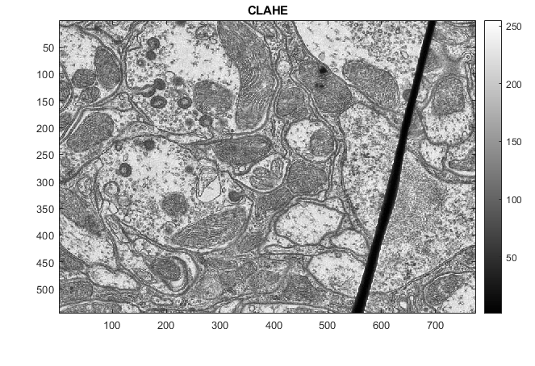

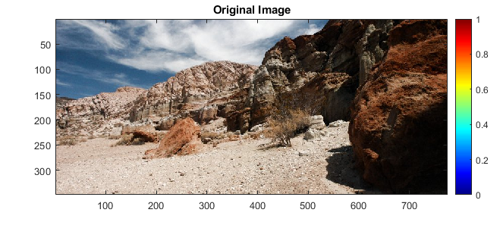

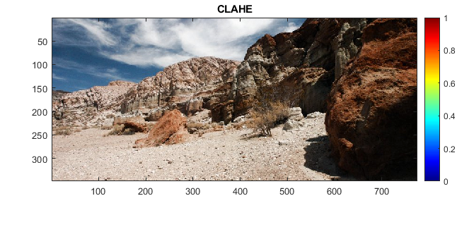

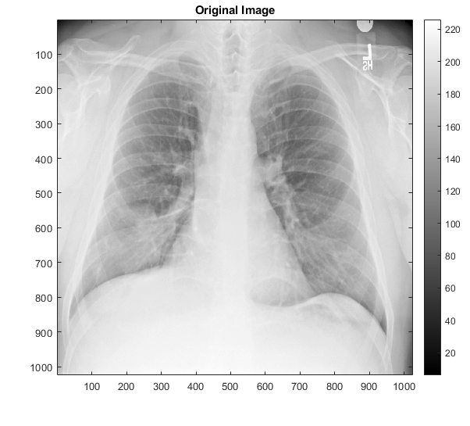

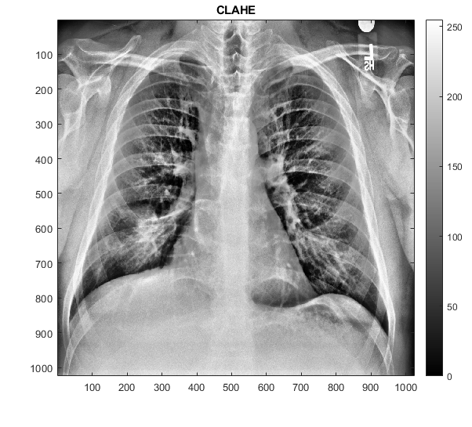

[*Published with MATLAB® R2020a*](https://www.mathworks.com/products/matlab)